Implementing Machine Learning techniques for Cancer Prognosis

Gauresh Chavan, Kaushal Chaudhary and Mohit Ruke

Abstract—This research project presents an application of three machine learning (ML) algorithms: Logistic Regression on the Wisconsin Diagnostic Breast Cancer (WDBC) , Extra Tree Classifier on Wisconsin Prognostic Breast Cancer (WPBCC) dataset and Support Vector Classifier (SVC) on WPBC by measuring their classification test accuracy, and their sensitivity and specificity values. For the implementation of the ML algorithms, the dataset was partitioned in the following fashion: 70% for training phase, and 30% for the testing phase. The hyper-parameters used for all the classifiers were manually assigned. Results show that all the presented ML algorithms performed decently on the classification task.

INTRODUCTION
Breast Cancer is the most common form of cancer in women, affecting almost 12% of all women across the world. In recent years, the incidence rate keeps increasing and data show that the survival rate is 88% after first five years from diagnosis and 80% after 10 years from diagnosis. Early prediction of cancer is one of the most crucial steps in the follow-up process ^{[3]}. Over past few decades, scientists applied different methods, such as screening in early stage, so that types of cancer can be identifies before their symptoms. With advent of new technologies, a large amounts of cancer data are available to the research community. However, an accurate prediction of a disease outcome is still one of the challenging tasks for the researchers and physicians around the world ^{[2]}. In this paper, we will develop, using machine learning techniques, methods that will allow accurate prognosis of cancer.

BACKGROUND
Today, despite the many advances in early detection of diseases, cancer patients have a poor prognosis and the survival rates in them are low ^{[1]}. In cancer prediction/prognosis one is concerned with the following ^{[4]}:

1) classification of tumor
2) prediction of cancer recurrence and
3) prediction of cancer survivability.

In the first case, one is trying to predict the type of tumor (malign or benign) prior to the occurrence of the disease. In the second case one is trying to predict the likelihood of redeveloping cancer. In the third case one is trying to predict an outcome (life expectancy, survivability, progression, tumor-drug sensitivity) after the diagnosis of the disease. In the latter two situations the success of the prognostic prediction is obviously dependent on the success or quality of the diagnosis ^{[4]}.

METHODOLOGY

Dataset
The machine learning algorithms were trained to detect breast cancer using WDBC, WPBCC and WPBC Dataset. WDBC consists of features which were computed from a digitized image of a fine needle aspirate (FNA) of a breast mass. The said features describe the characteristics of the cell nuclei found in the image. There are 569 data points in the dataset: 212 – Malignant, 357 – Benign. Accordingly, the dataset features are as follows: (1) radius, (2) texture, (3) perimeter, (4) area, (5) smoothness, (6) compactness, (7) concavity, (8) concave points, (9) symmetry, and (10) fractal dimension. With each feature having three information: (1) mean, (2) standard error, and (3) “worst” or largest (mean of the three largest values) computed. Thus, having a total of 30 dataset features. WPBCC consists of patient’s nuclear features from WDBC, survival and chemotherapy information. WPBC consists of nuclear features and recurrence information in terms of months ^{[8]}.

Machine Learning Library
TPot^{[6]} was used to automatically optimize a series of feature preprocessors and models that maximize the cross-validation accuracy on the dataset along with scientific computing libraries like Pandas, Matplotlib, seaborn and Scikit-learn to implement machine learning algorithms.

Data Preprocessing
To avoid inappropriate assignment of relevance, the data has been scaled using following formula:
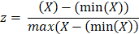
Where X is the feature to be scaled and the range is given by the denominator.

Machine Learning Methods
1. Support Vector Classifier (SVC):
SVC is a supervised machine learning algorithm that can be used for both classification and regression problems but is mostly used for classification ^{[7]}. Its main objective is to determine the optimal hyperplane given by:
f (w, x) = w · x +b
separating two classes in a given dataset having input features x ∈ R p, and labels y ∈ {−1, +1} ^{[5]}. However, SVM is sensitive to scaling. Therefore, both train and test data are scaled to retrieve true positives and false positives. In case of SVM, finding the right parameters to arrive at optimal accuracy is a tough task. To solve this problem, we created a grid of parameters using a common enough function within scikit-learn called GridSearchCV. It takes a dictionary that describes the parameters that should be tried on the model to train. The implementation of code may be found on https://github.com/karmickoala31/appledore
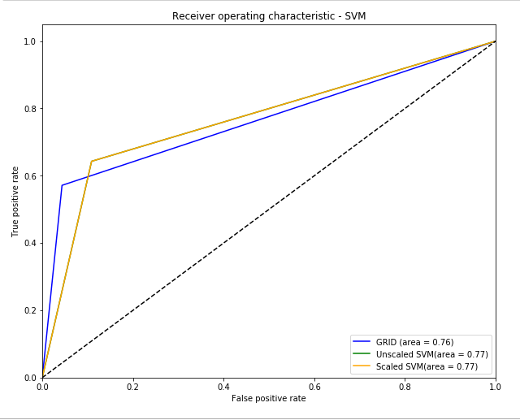
Figure 1: Plotted using matplotlib. Receiver operating characteristics for SVMs on WPBC

2. Logistic Regression:
In Logistic Regression outcome is measured with a dichotomous variable (in which there are only two possible outcomes). It is used to predict a binary outcome (1 / 0, Yes / No, True / False) given a set of independent variables ^{[9]}. In WDBC, ‘diagnosis’ feature gave categorical values M(Malignant) and B(Benign) which were converted to (1,0) using a function in python.
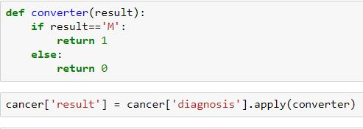
Figure 2: Implemented in Jupyter notebook.

Model results were validated using L2 regularization which comes default with the Logistic Regression. Strength of regularization, C, however was changed to observe changes in the accuracy. The Model was further evaluated by plotting roc curve. The implementation of code may be found on https://github.com/karmickoala31/appledore
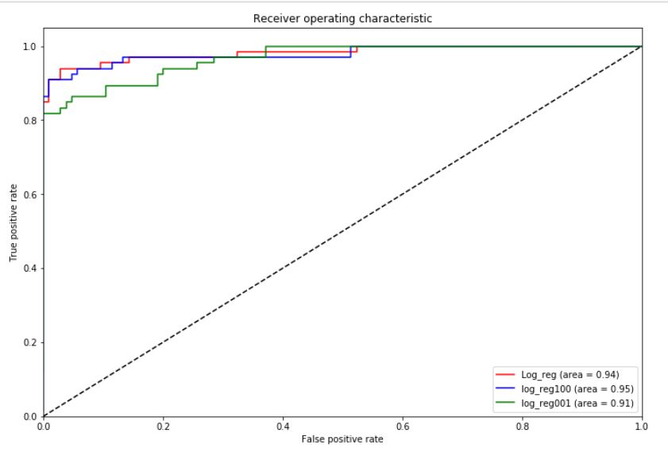 Figure 3: Plotted using matplotlib. Receiver Operating Characteristics for Logistic Regression on WDBC.

3. Extra Tree Classifier:
It essentially consists of randomizing strongly both attribute and cut-point choice while splitting a tree node. In the extreme case, it builds totally randomized trees whose structures are independent of the output values of the learning sample. The strength of the randomization can be tuned to problem specifics by the appropriate choice of a parameter ^{[10]}.

Extra-Trees splitting algorithm (for numerical attributes): Split a node(S)
Input: the local learning subset S corresponding to the node we want to split Output: a split [a < ac] or nothing
– If Stop split(S) is TRUE then return nothing.
– Otherwise select K attributes {a1,..., aK } among all non-constant (in S) candidate attributes;
– Draw K splits {s1,...,sK }, where si = Pick a random split(S, ai), ∀i = 1,..., K;
– Return a split s∗ such that Score(s∗, S) = maxi=1,...,K Score(si, S).
Pick a random split(S,a)
Inputs: a subset S and an attribute a
Output: a split
– Let aS max and aS min denote the maximal and minimal value of a in S;
– Draw a random cut-point ac uniformly in [aS min, aS max]; – Return the split [a < ac].
Stop split(S)
Input: a subset S
Output: a boolean
– If |S| < nmin, then return TRUE;
– If all attributes are constant in S, then return TRUE;
– If the output is constant in S, then return TRUE;
– Otherwise, return FALSE.
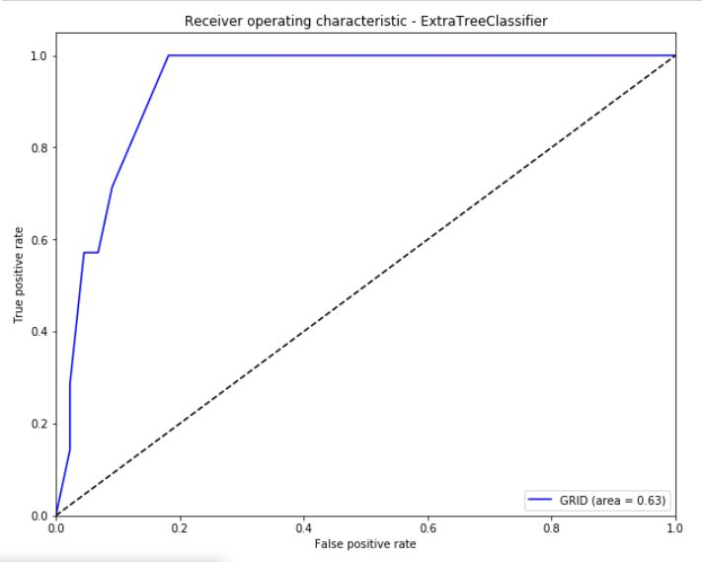
Figure 4: Plotted using matplotlib. Receiver operating characteristic for Extra Tree Classifier on WPBCC

ANALYSIS
There were two phases of experiment for this study: (1) training phase, and (2) test phase. The dataset was partitioned by 70% (training phase) / 30% (testing phase). The parameters considered in the experiments were as follows: (1) Train Accuracy, (2) Test Accuracy, (3) False Positive (FP), (4) False Negative (FN), (5) True Positive (TP), and (6) True Negative (TN)

RESULTS AND DISCUSSION
Parameter | Logistic Regression | SVC | Extra Tree Classifier
Train Accuracy | 0.977 | 0.877
Test Accuracy | 0.944 | 0.817
Precision | 0.95 | 0.81
Recall | 0.95 | 0.82
f1-score | 0.95 | 0.80
roc | 0.94 | 0.79

ACKNOWLEDGEMENT
Deep appreciation and a vote of thanks for all the respective authors mentioned in the references.

VIII. REFERENCES
[1] Azadeh Bashiri, Marjan Ghazisaeedi,* Reza Safdari, Leila Shahmoradi, and Hamide Ehtesham. Improving the Prediction of Survival in Cancer Patients by Using Machine Learning Techniques: Experience of Gene Expression Data: A Narrative Review
[2] Konstantina Kourou, Themis P. Exarchos, Konstantinos P. Exarchos, Michalis V. Karamouzis, Dimitros I. Fotiadis. Machine learning applications in cancer prognosis and prediction.
[3] Using Three Machine Learning Techniques for Predicting Breast Cancer Recurrence
Ahmad LG*, Eshlaghy AT, Poorebrahimi A, Ebrahimi M and Razavi AR
[4] Applications of Machine Learning in Cancer Prediction and Prognosis Joseph A. Cruz and David S. Wishart
[5] On Breast Cancer Detection: An Application of Machine Learning Algorithms on the Wisconsin Diagnostic Dataset Abien Fred M. Agarap

[6] http://www.randalolson.com/2016/05/08/tpot-a-python-tool-for-automating-data-science/

[7] https://www.analyticsvidhya.com/blog/2017/09/understaing-support-vector-machine-example-code/

[8] ftp://ftp.cs.wisc.edu/math-prog/cpo-dataset/machine-learn/cancer/

[9] https://towardsdatascience.com/machine-learning-part-3-logistics-regression-9d890928680f
[10] https://orbi.uliege.be/handle/2268/9357

